PHYSICS

Stage 2

Sample WACE Examination 2010

Marking Key
Marking keys are an explicit statement about what the examiner expects of candidates when they respond to a question. They are essential to fair assessment because their proper construction underpins reliability and validity.
When examiners design an examination, they develop provisional marking keys that can be reviewed at markers’ meetings and modified as necessary in the light of student responses.
This marking key has been developed by examiners in conjunction with the sample examination paper and, as is the case with any external examination developed by the Curriculum Council, is a provisional document that can be modified if necessary in the light of student responses.

Section One: Short answer 64 Marks

A parachutist has opened her parachute and is drifting towards the ground at 4.80 m s⁻¹.
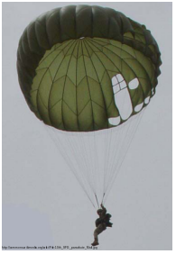

(a) Use the image below to draw a free body diagram showing the force(s) acting on her.
(1 mark)

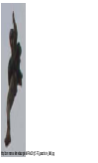

(b) When the ground is 1.48 × 10³ m below her, a thermal causes an updraft of air to occur at 1.84 m s⁻¹. This upwards current of air continues during the entire descent.

(i) Calculate the parachutist’s resultant velocity. (2 marks)

- How long does it take the parachutist to reach the ground with the thermal affecting the decent? (2 marks)

Description | Marks
(a) Arrows as drawn (up and down, equal lengths) | 1
(b)v_{T} = v₁ + v₂  v_{T} = 4.80 + -1.84 | 1
v_{T} = 2.96 m s⁻¹ (down) | 1
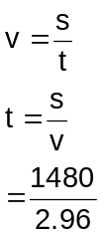 | 1
t = 500 s | 1
 | Total 5

Question 2 (2 marks)

If an atom gains two electrons, what is the charge, in coulombs, of the resulting ion? Explain your reasoning.

Description | Marks
The ion charge must be -3.2 × 10⁻¹⁹ C | 1
Because each electron has charge -1.6 × 10⁻¹⁹ C | 1
 | Total 2

Question 3 (4 marks)

Below is an image of a small dog taken using a thermographic camera.

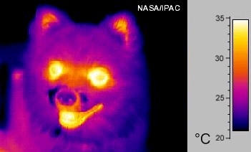

(a) What method of heat transfer does the camera use to detect the dog? (1 mark)

(b) The image displays a range of temperatures on the surface of the dog despite the internal temperature of the animal being constant. Why would there be a difference in the surface temperatures? (3 marks)

Description | Marks
(a) Radiation | 1
(b) There are different levels of insulation and heat conduction to the different surfaces of the dog. | 1
Fur acts as an insulator and lets through less heat keeping it cooler | 1
compared to the mouth and eyes where there is thin skin, allowing more conduction and hotter surfaces | 1
 | Total 4

Question 4 (4 marks)
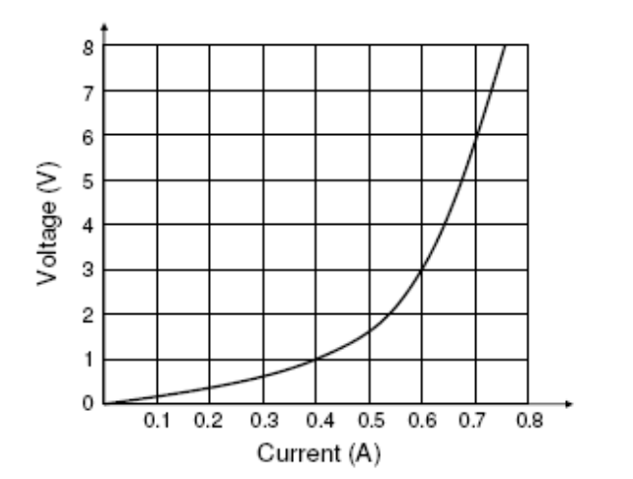
A graph of a non-ohmic resistor is shown to the right.

(a) Calculate the resistance when there is 0.40 A of current flowing through the resistor. (2 marks)

(b) Calculate the resistance when a potential difference of 6.0 V is across the resistor. (2 marks)

Description | Marks
(a) 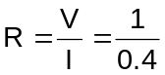 | 1
= 2.5 Ω | 1
(b) 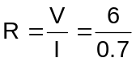 | 1
= 8.6 Ω (mark off if more than 2 sig figs) | 1
 | Total 4

Question 5 (4 marks)

One gram of carbon from a wooden spoon is tested and found to give, on average, 0.270 Bq of ionising radiation. The half life of radioactive carbon is approximately 5730 years. One gram of carbon is obtained from an archaeological site. Over a one hour period, 486 counts are registered on a Geiger counter.

(a) How many Becquerel does this correspond to? (1 Bq = 1 decay per second) (1 mark)

(b) How many years older than the spoon is the sample from the site? (3 marks)

Description | Marks
(a) Bq = counts s⁻¹ = 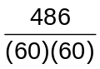= 0.135 | 1
(b) A = A₀(½)^{n} ; 0.135 = 0.270(½)^{n} ; n = 1.0 | 1
Age = n × t_{½} = 1.0 × 5730 | 1
= ~5.7 × 10³ years | 1
 | Total 4
Question 6 (3 marks)

Shannon has a stair climbing competition with her father to climb 6 flights of stairs and Shannon wins the competition. Shannon’s mass is 30.0 kg and her father's mass is 70.0 kg. Which statement is correct?

- Shannon’s father does more work
- Shannon does more work
- Shannon’s father has exerted more power
- Shannon has exerted more power
- Shannon and her father do equal amounts of work.

Correct statement: _________
Explain your choice.

Description | Marks
A | 1
W = force × distance and 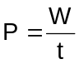 | 1
We can not compare the powers contributed by Shannon and Shannon’s father because we don’t know the time they spent. | 1
 | Total 3

Question 7 (5 marks)

An electric circuit is shown in the diagram below. A DC voltage of 10 V is applied between A and B. The values of the resistors are R₁ = 20 Ω, R₂ = 5 Ω, R₃ = 100 Ω and R₄ = 25 Ω.
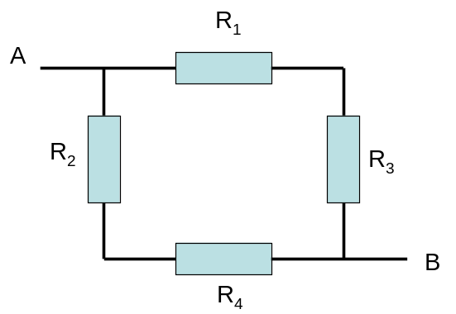

(a) Calculate the total resistance, R_{T}. (3 marks)

(b) Determine the current (I_{T}) between A and B. (2 marks)

Description | Marks
(a) R_{1,3} = 20 +100 = 120  R_{1,3} = 120 Ω | 1
R_{2,4} = 5 + 25 = 30  R_{2,4} = 30 Ω | 1
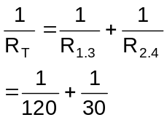  R_{T} = 24 Ω | 1
(b) 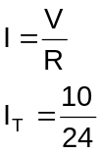 | 1
= 0.42 A | 1
 | Total 5

Question 8 (3 marks)

Radiation workers wear a film dosimeter to monitor exposure to ionizing radiation. A typical badge is constructed to determine exposure levels and to what types of radiation.
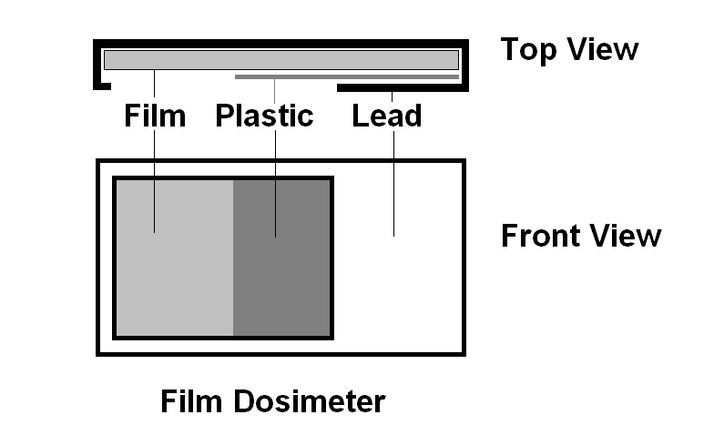

(a) How is the badge able to show how much radiation the worker was exposed to? (1 mark)

(b) How is the badge able to show what type of radiation the worker was exposed to? (2 marks)

Description | Marks
(a) When the film is hit by ionising radiation, the film darkens. The more exposure the darker the film | 1
(b) The filters act to block out the different particles | 1
Relate penetrating property to exposure areas eg lead blocks alpha and beta, so only gamma exposes film; plastic blocks alpha letting thru gamma and beta, take away gamma section to tell amount of beta. Alpha can only expose the open section, subtract amount form other sections for amount. | 1
 | Total 3

Question 9 (2 marks)

A coin is dropped down a well. Determine the depth, s, of the well if it took the coin 1.25 s to reach the bottom.

Description | Marks
s =ut+ ½ at²  s=0 × 1.25 + ½ 9.8 × 1.25² | 1
s= 7.65 m | 1
 | Total 2

Question 10 (3 marks)

Below is a graph of binding energy curve for common isotopes.

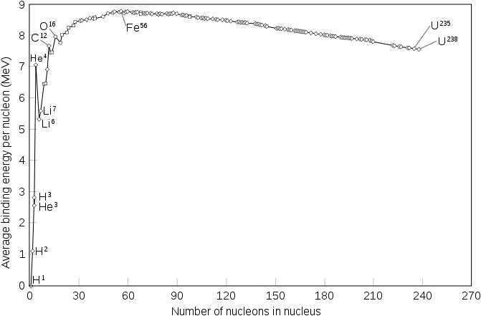

(a) Using information from the graph, state which is more stable: uranium-235 or
uranium-238. (1 mark)

(b) Uranium-238 has a half life of 4.47 × 10⁹ years and uranium-235 has a half life of
7.05 × 10⁸ years. Given a sample of uranium-238 and a sample of uranium-235, each containing an equal amount of atoms, explain which sample would have a higher reading on a Geiger counter. (2 marks)

Description | Marks
(a) Higher binding energy per nucleon | 1
(b) U-235 would have a higher reading | 1
It has a shorter half life, so is more likely to decay | 1
 | Total 3
Question 11 – 13 are based on the following information.

A solar heating system consists of a unit that may be mounted on the sloping roof of a house to produce warm water that is stored in a tank. 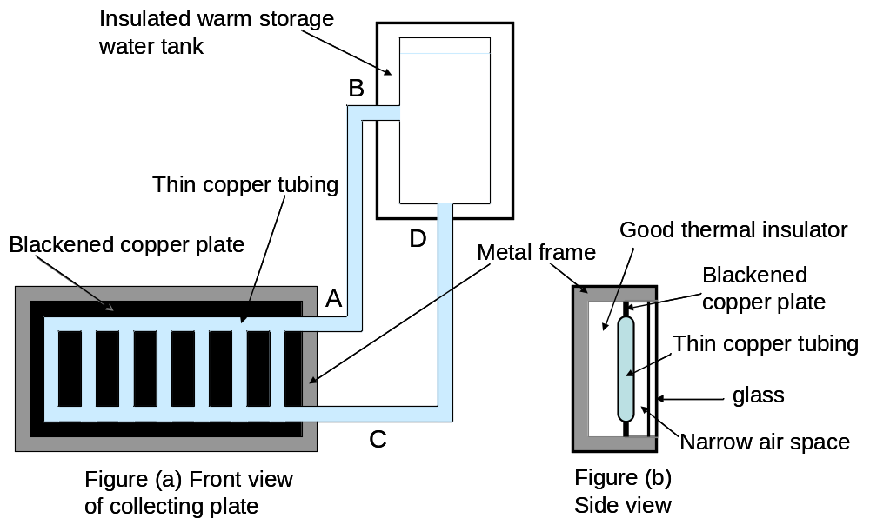

In figure (a) the solar energy collecting plate consists of a thin-walled copper tube embedded in a copper plate. The surface of the copper is blackened. This is mounted in a special metal frame, as shown in figure (b).

Sunlight irradiates the blackened panel through a glass window and heat is conducted to the water inside the copper tube which is warmed and stored in the insulated water tank. The space behind the copper plate and tube is filled with a good thermal insulator.

Question 11 (3 marks)

(a) Why is it necessary to place the insulated water tank at a higher level than that of the solar collection panel? (2 marks)

(b) Which of the two pipes AB or CD carries the warmer water? (1 mark)

Description | Marks
(a) Hot water is less dense and rises into the tank. | 1
The colder and denser water in the tank flows down the bottom pipe on the panel to be heated. | 1
(b) AB carries the warmer water. As the water is heated by the panel the warmer water rises from the bottom pipe CD through the vertical tubes to the top pipe AB. | 1
 | Total 3
Question 12 (3 marks)

Solar hot water heaters often have a pressure valve. On a hot day, there is often hot water that flows out from the valve. Why is a pressure valve needed where the temperature of the water varies?

Description | Marks
The Kinetic Theory states that “hotter” objects contain more energy and are more energetic | 1
This energy expands (or increases pressure if volume constant) the water so that it takes up more space | 1
Without room for expansion or pressure relief, the tank could burst | 1
 | Total 3

Question 13 (3 marks)

The blackened copper plate section contains equal masses of copper (c_{Cu} = 390 J kg⁻¹ K⁻¹) and water (c_{w} = 4120 J kg⁻¹ K⁻¹). Explain which contains more energy, the copper or the water.

Description | Marks
They are both at the same temperature | 1
Therefore the particles (on average) have the same kinetic energy. Water will have the greater amount of energy | 1
The greater the specific heat the more energy that can be given for the same change in temperature | 1
 | Total 3

Question 14 (4 marks)
024

Time (s)
F (N)

15

10

5

0

The graph shows the net force on a 1.25 kg remote control car as it accelerates from rest at the start of a race.

(a) Calculate the car’s momentum 2.5 s after
the start. (2 marks)

(b) Calculate the car’s speed 2.5 s after the start. (2 marks)

Description | Marks
(a) mv – mu = Ft;  mv – 0 = 15 × 2.5 | 1
p = mv  = 37.5 kg m s⁻¹ | 1
(b) v = p/m  = 37.5/1.25 | 1
= 30 m s⁻¹ | 1
 | Total 4

Question 15 (5 marks)

A 1500 kg car is travelling east at 15.0 m s⁻¹ when it crashes into a 2500 kg truck travelling in the same direction at 12.0 m s⁻¹. The car has a velocity of 13.0 m s⁻¹ after the collision. Assuming this is an inelastic collision, determine:

(a) the speed of the truck just after the collision; (2 marks)

(b) how much kinetic energy is lost during the collision. What is this kinetic energy converted into? (3 marks)
Description | Marks
(a) 1500 × 15+2500 × 12 = 1500 × 13 + 2500 × v | 1
v = 13.2 m s⁻¹ | 1
(b) ½ 1500 × 15² + ½ 2500 × 12² – ½ 1500 × 13² – ½ 2500 × 13.2² | 1
= 168750 + 180000 – 126750 – 217800 = 4200 J | 1
Heat and/or sound | 1
 | Total 5

Question 16 (5 marks)

A fission reaction used for nuclear power plants is the splitting of Uranium-233 through thermal neutron absorption. One possible fission event produces Tellurium-133 and Zirconium-97 as daughter isotopes.

(a) Complete the reaction by filling in how many neutrons are produced. (1 mark)

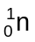 + 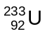 → 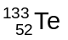 + 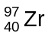 + _____ + energy

(b) Determine the mass defect and the energy (in joules) produced from this reaction given the masses of uranium-233 (3.86846 × 10⁻²⁵ kg) tellurium-133 (2.20632 × 10⁻²⁵ kg) and zirconium-97 (1.60872 × 10⁻²⁵ kg). (4 marks)

Description | Marks
(a) 4 | 1
(b) M_{d} = (n + U-233) – (Te-127 + Zr-93 + 4n)  M_{d} = (1.68 × 10⁻²⁷ + 3.86846 × 10⁻²⁵) – (2.20632 × 10⁻²⁵ + 1.60872 × 10⁻²⁵ + 4 × 1.68x10⁻²⁷) | 1
M_{d} = 3.01 × 10⁻²⁸ kg | 1
E = mc² = 3.01 × 10⁻²⁸ × (3 × 10⁸)² | 1
E = 2.71 × 10⁻¹¹ J | 1
 | Total 5

Question 17 (6 marks)

Two metal plates, A and B, are connected to a voltage source so they are charged. A stationary electron is initially placed at position P, between plates A (charge = -Q) and
B (charge = +Q), as shown in the following figure. Ignore the gravitational force on the electron.
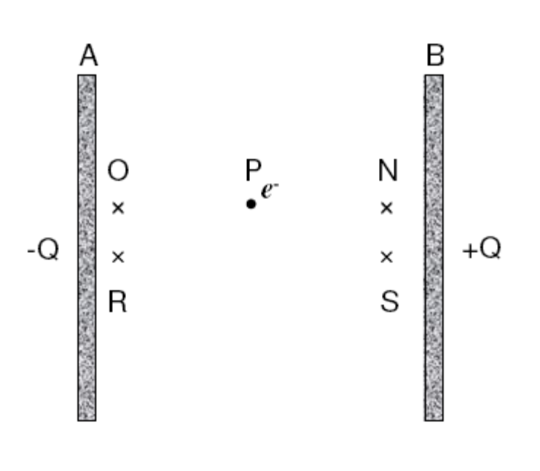

(a) Select the correct statement from the following, and explain your reasoning. (3 marks)

- The electron stays where it is.
- The electron moves at a constant velocity from P to R.
- The electron moves at a constant acceleration from P to N.
- The electron moves at a constant acceleration from P to O.
- The electron moves at an increasing acceleration from P to N.
- The electron moves at a constant acceleration from P to S.

Correct answer is: ________

(b) On the diagram above, draw a possible trajectory (path) of the electron after it is released at P. (1 mark)

(c) When the electron moves from P to N, its electric potential energy is: (1 mark)

- Increased.
- no change.
- Decreased.

Correct answer is: _________

(d) After the electron has travelled some distance, its kinetic energy is (1 mark)

- increased.
- unchanged.
- decreased.
Answer:

Description | Marks
(a) C | 1
The electric field is uniform | 1
so it exerts a constant force on the electron | 1
(b) a straight line from P to N | 1
(c) C | 1
(d) A | 1
 | Total 6

End of Section One
Section Two: Extended answer (80 Marks)

Question 18 (11 marks)
Chris rides a motorcycle starting from rest and moving north. The displacement (s) travelled over time (t) is shown in the s versus t graph below.
150
100
50
0
-
50
-
100
-
150
-
200
(m)
t
(s)
200
-
-
-
-
(m)
t
(s
s (m)
North
5 10 15 20 25 30 35 40 50
South

(a) Calculate the average velocity between t = 0 and t = 10 s. (2 marks)

(b) Calculate the distance that Chris travels between t = 10 s and t = 35 s. (1 mark)

(c) Calculate Chris’s average speed between t = 0 and t = 40 s. (2 marks)

(d) Calculate Chris’s displacement between t = 0 and t = 40 s. (2 marks)

(e) Determine Chris’s average velocity between t = 15 s and t = 40 s. (1 mark)
(f) Using the information in the graph, draw a graph of velocity versus time (v versus t) for the journey. (2 marks)
0 5 10 15 20 25 30 35 40
v (m s⁻¹)

t (s)
40
30
20
10
0
-
10
-
20
-
30
-
40
-
-
-
-

(g) If Chris spends another 5.00 s to return back to the starting point, calculate the average velocity for the entire journey. (1 mark)

Description | Marks
(a)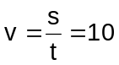 | 1
= 15 m s⁻¹ | 1
(b) s = 0 m + 150 m + 200 m + 50 m = 400 m | 1
(c) 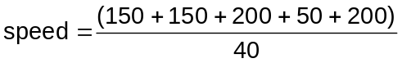 | 1
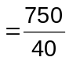 = 18.75 m s⁻¹ | 1
(d) 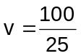 | 1
= 4 m s⁻¹ (north) | 1
(e) Displacement = 50 m | 1
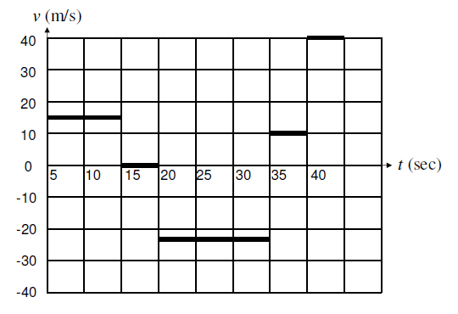  (f) | 2
(g) 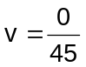 = 0 m s⁻¹ | 1
 | Total 11

Question 19 (12 marks)

A 1.20 kilogram sample of an unknown material was heated in the lab. The graph below shows how the temperature of the material changes as heat energy was added to the material.

(a) Which phase has the greatest specific heat capacity? (3 marks)

Circle the correct answer: Solid Liquid Gas

Explain the reasoning behind your answer.

(b) Use the graph to determine the following information for the sample in the liquid phase.

  - The rise in temperature between phase changes (1 mark)

(ii) The amount of energy required to complete this temperature change (1 mark)

(c) Calculate the specific heat capacity of this material in the liquid phase. (2 marks)

(d) Calculate the latent heat of vaporisation for this unknown material. (3 marks)

(e) Using the Kinetic Theory and idea of internal energy, describe the particles of the material at point A on the graph. (2 marks)

Description | Marks
(a) Gas | 1
The gas section has a lower gradient | 1
This requires more energy before the temperature will change | 1
(b) (i) ΔT = (250 – 75) °C = 175 °C | 1
(ii) Q = (10 × 10⁵) – (7 × 10⁵) = 3 × 10⁵ J | 1
(c) 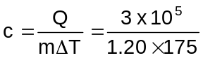 | 1
c = 1.43 × 10³ J kg⁻¹ K⁻¹ | 1
(d) Q = 25 - 10 = 15 × 10⁵ J (value from graph) | 1
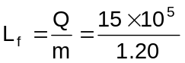 | 1
L_{f} = 1.25 × 10⁶ J kg⁻¹ | 1
(e) The particles are gaining internal energy as the material is heated | 1
as the average kinetic energies of the particles increase, the more energetic ones leave the liquid surface (evaporate) | 1
 | Total 12
Question 20 (13 marks)

A Physics student wanted to create a circuit using three light globes. She did not have three globes that were the same, and made the circuit below.
+ 12V -
Power Supply

L₂
L₁
L₃

(a) On the diagram above, draw in the following:

(i) a switch ( ) so that only light globe L₁ is affected. (1 mark)

(ii) an ammeter ( ) to measure the current through light globe L₂. (1 mark)

A

(iii) a voltmeter ( ) to measure the potential difference for light globe L₂.

V
(1 mark)

(b) Which way does conventional current flow? (1 mark)

Circle the correct answer: L₂ to L₃ L₃ to L₂ L₁ to L₂.

(c) Explain any changes to the brightness of L₁ and L₃ that occur if L₂ blows (breaks).
(2 marks)

(d) Light globe L₁ is rated at 12.0 V and light globe L₂ is rated at 9.00 V. What should light globe L₃’s voltage rating be to maintain 9.00 V across light globe L₂? (1 mark)

(e) Both L₁ and L₂ have a power rating of 10.0 watts.

(i) Calculate the resistance of L₁. (2 marks)

(ii) Calculate the total current delivered by the power supply. (4 marks)

Description | Marks
(a) (i) Anywhere along the L₁ circuit (separate to L₂ and L₃) | 1
(ii) Anywhere separate to L1, in line with L₂ and L₃ | 1
(iii) Across only L₂ | 1
(b) L₂ to L₃ | 1
(c) L₃ will go out | 1
and L₁ will remain unchanged (may go brighter if power supply does not have a good supply of current and more current is available) | 1
(d) 12.0 – 9.00 = 3.00 V | 1
(e)(i) 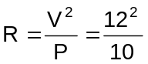 | 1
R = 14.4 Ω | 1
(ii) 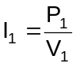 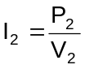 | 1
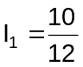 = 0.833 | 1
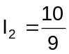 = 1.11 | 1
I_{T} = I₁ + I₂= 0.833 + 1.11 = 1.94 A | 1
 | Total 13

Question 21 (16 marks)
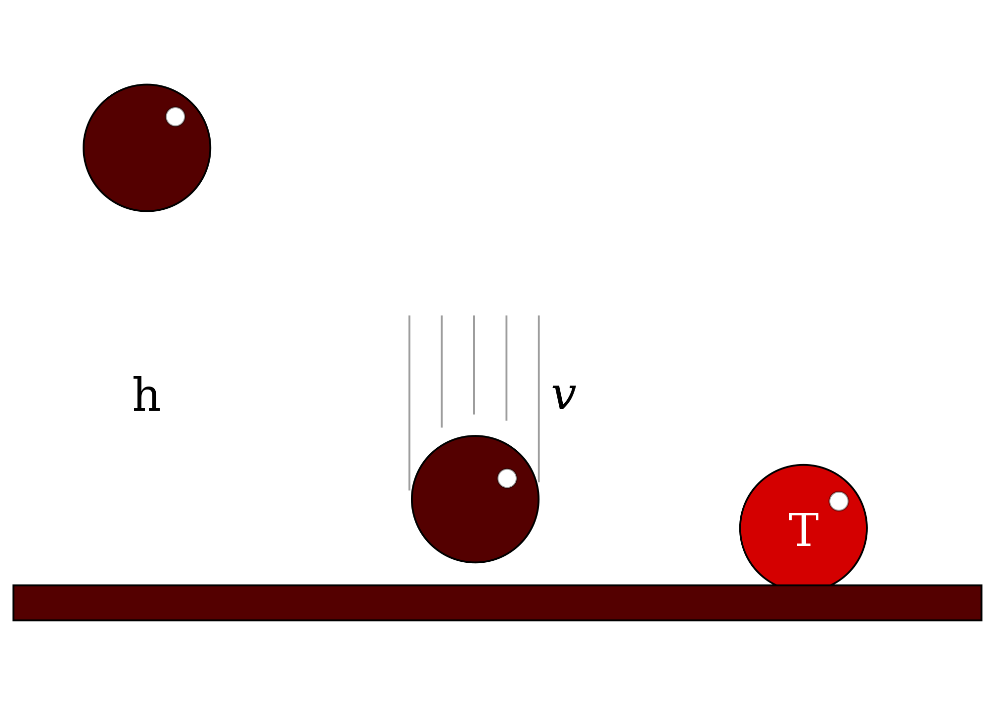
An 'unhappy ball' consists of an energy absorbing polymer,
called polynorbornene, which absorbs kinetic energy and
prevents it from bouncing.

A 10.3 gram 'unhappy ball' is dropped from an initial
height (h) of 2.50 m.

(a) How much potential energy does the ball have initially? (2 marks)

(b) What is the ball’s velocity when it hits the ground? (2 marks)

(c) If all the energy was absorbed by the ball and converted into internal energy, calculate how much the ball’s temperature rises. (c_{polynorbornene} = 2.09 × 10³ J kg⁻¹ K⁻¹) (3 marks)

(d) In reality, the ball is not 100% efficient at absorbing energy. What are two other possible losses of energy that could have occurred? (2 marks)

A 'happy ball' is made of polychloroprene that attempts to return all of the ball's kinetic energy so that it bounces as high as it can. One of the factors affecting how high the ball will bounce is the temperature of the ball. Below is a temperature versus height of bounce graph from an experiment conducted by high school students during a physics lesson.
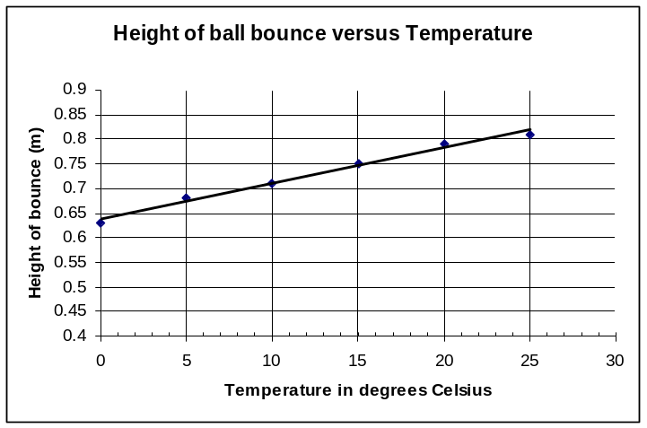

(e) (i) Name the independent variable in this experiment. (1 mark)

- Name the two variables that should be controlled. (1 mark)

(f) The graph shows a linear relationship. Predict the height of bounce when the temperature is 50 °C. (2 marks)

(g) This photo shows one of the trial bounces. Measuring from the top of the ball,
(3 marks)

(i) estimate the height of the bounce.

- estimates the absolute uncertainty in the bounce height measurement.

(iii) Using the graph above, to what temperature does this bounce correspond?
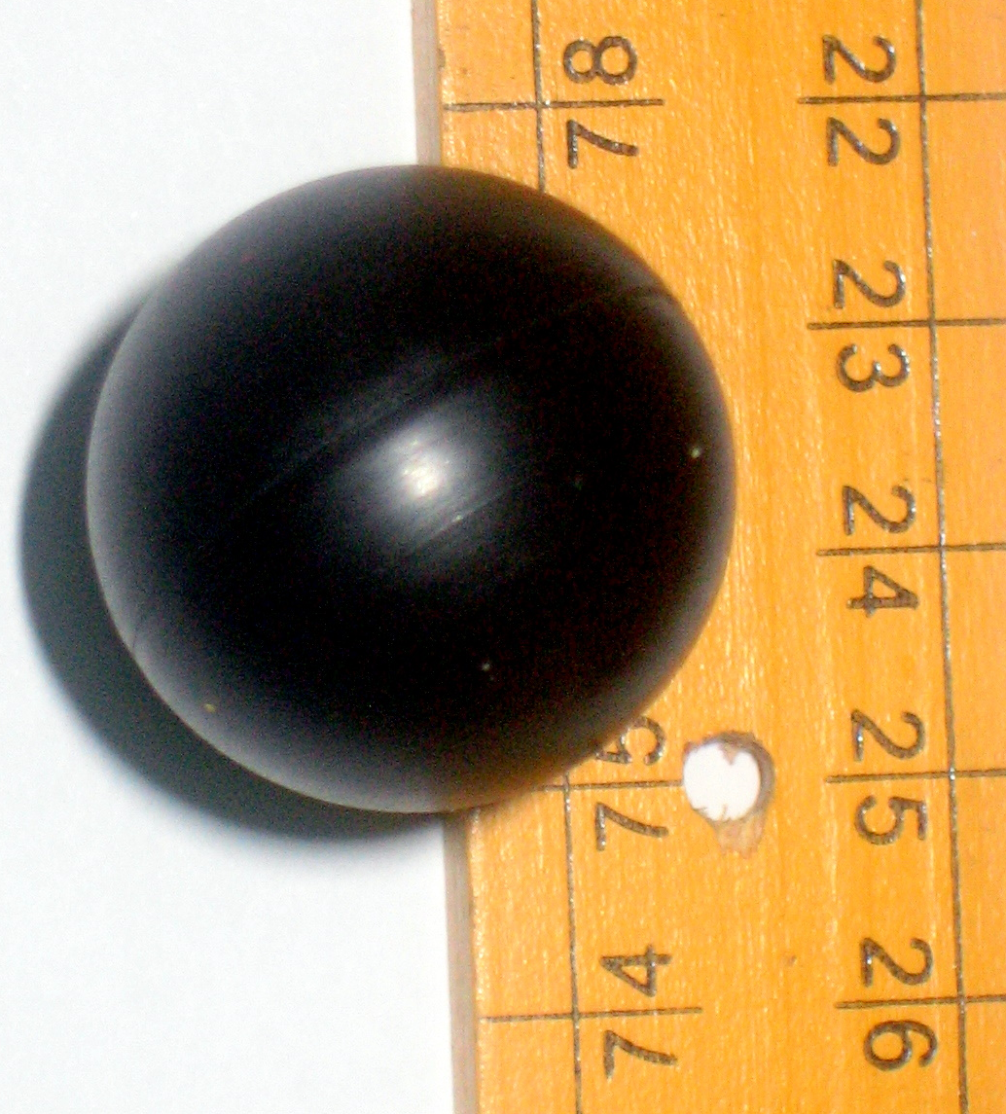

Description | Marks
(a) Ep = mgh= 0.0103 × 9.8 × 2.5 | 1
= 0.25235 J | 1
(b) v² = u² + 2as or Ep = Ek = ½ m v²  = √ (0² + 2 × 9.8 × 2.5) 0.25235J = ½ 0.0103 v² | 1
v = 7 m s⁻¹ v = 7 m s⁻¹ | 1
(c) ΔT = Q/mc | 1
= 0.25235/(0.0103 × 2.09 × 10³) | 1
= 0.0117 °C | 1
(d) Possible answers – Lose of speed due to wind resistance; Floor absorbs some of the energy; converts to sound energy; bounced a little; etc | 2
(e)(i) Temperature | 1
(ii) Surface bounced on; height of drop; ball; atmospheric pressure; etc. | 1
(f) The height of bounce will get too close to the drop height of 1m if it stays linear | 1
so it should flatten out. | 1
(g)(i) 75 cm | 1
(g)(ii) ± 0.5 cm | 1
(g)(iii) 15 °C | 1
 | Total 16

Question 22 (12 marks)

Radon-222 (half life 3.83 days) is a naturally occurring gaseous isotope of radon that forms from the alpha decay of radium-226 (half life 1.6 × 10³ years). It is found in most soils and hence building materials and consequently buildings. Because it is gaseous and its decay releases tissue damaging radiation, it can cause lung cancer when inhaled into the lungs over a prolonged period.

(a) Write the equation for the alpha decay of radium-226 (atomic number 88) to radon.
(2 marks)

(b) Radon also undergoes alpha decay. Why are these alpha particles so much more dangerous to humans than those released by the parent radium? Explain your answer.
(3 marks)

(c) If there are 5.00 × 10⁸ radon atoms trapped in a closed room at a given point in time, how many will be left 11.5 days later? Assume no more radon is emitted by the building materials. (3 marks)

(d) A person stayed in the closed room in (c) above for four days.
(i) Determine the maximum possible absorbed dose this person could receive if they had a mass of 70 kg and the energy released by the alpha disintegration of radon during this time was 0.15 J. (2 marks)

(ii) Determine the maximum dose equivalent of this radiation. (2 marks)

Description | Marks
(a) 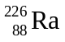→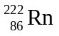 + 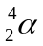 + energy | 2
(b) The alpha particles released by radium are external to the body | 1
being short range, are easily stopped by air, clothing and the external dead skin cells so few have an effect on living tissue | 1
The fact that radon is a gas means it enters the lungs and is in direct contact with the lung tissue. The alpha particles released are directly absorbed by living lung cells and, being highly ionizing, can cause transmutations in these cells which potentially can lead to forms of lung cancer | 1
(c) Number of half lives = 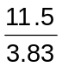  = 3 half lives | 1
Number of atoms remaining after 3 half lives (N) 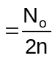 | 1
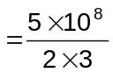 = 6.25 × 10⁷ atoms | 1
(d) Absorbed dose= energy released/mass= 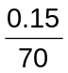 Gy | 1
=2.143 × 10⁻³ Gy | 1
(e) Dose equiv = absorbed dose x quality factor= 2.143 × 10⁻³ × 20 | 1
= 4.29 × 10⁻² Sv | 1
 | Total 12
Question 23 (16 marks)

Jamie is a model train enthusiast and has some identical trains that operate within a voltage range of 12 ± 3 V and at a minimum current of 1.00 A. Jamie also has several sets of tracks. Each set of tracks has its own separate 12.0 V and 4.00 A power connections as shown.

(a) If one of the trains draws a current of 2.5 A, calculate the resistance of its motor. (2 marks)

(b) Jamie places two trains identical to the one in (a) above the same track (with one power supply). Calculate the total current and power now drawn from the power supply. (3 marks)

(c) With these two identical trains on a track at the same time, how does their speed vary compared to the speed of the single train? (3 marks)

Circle the correct answer. Slower Same as Faster

Explain your answer, and show calculations.

(d) Jamie wonders if it is possible to increase the number of trains run by one power supply. In relation to voltage and current, which of the following properties would a new power supply need to have to be able to run more trains on the same set of tracks? (4 marks)

Circle the correct answers.
The voltage needs to be: the same larger reduced

The current needs to be: the same larger reduced

Explain the reasons for your choices.

(e) A short circuit occurs where a current flows through the metal body of the train, causing it to heat up. If 3.00 kJ of electrical energy was passed into the 0.450 kg train which raised its temperature by 17.5 °C, determine the specific heat of the alloy used for the train. (2 marks)

(f) Name an electrical device that could protect the motor and other electronic components in the transformer if a short circuit should occur. Describe with a diagram how you would place this device in the circuit. (2 marks)

Description | Marks
(a) 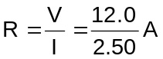 | 1
= 4.8 Ω | 1
(b) When two motors (or resistances) are in parallel:  R_{T} =  = 2.4 Ω | 1
Total current required by two trains 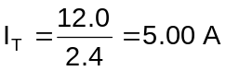 | 1
However the maximum current provided by a single power supply is 4 A and the maximum power P equals 12.0 V × 4 A = 48 W | 1
(c) Slower | 1
A single train placed on the track, the power supply provides power P = 12.0 × 2.5 = 30 W | 1
Two trains placed on the track. Each train draws 24 W from the power supply, so that both trains run slower. | 1
(d) Voltage - same | 1
Current - larger | 1
The voltage range of the train motor is (12 ± 3 V) therefore the motor will burn out at values greater than this as the current drawn is too large (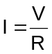) and will not work at values less than this as the current, and hence power, will be too low. Therefore the voltage must remain the same. | 1
The current must increase to provide sufficient power (P = I²R) for the motor to drive the train on the tracks as the resistance does not change. | 1
(e) 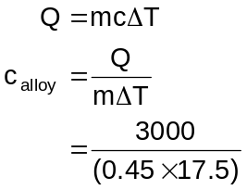 | 1
c_{alloy} = 381 J kg⁻¹ K⁻¹ | 1
(f) Fuse, bimetallic strip: can open the low voltage circuit and stop the flow of current. We can place these in series with the output of the power supply or input of the motor of each train | 1
The transformer can be protected by using a fuse or circuit breaker in the active side of the mains circuit or a RCD across the active and neutral. | 1
 | Total 16

End of Section Two
Section Three: Extended Answer (16 Marks)

Question 24
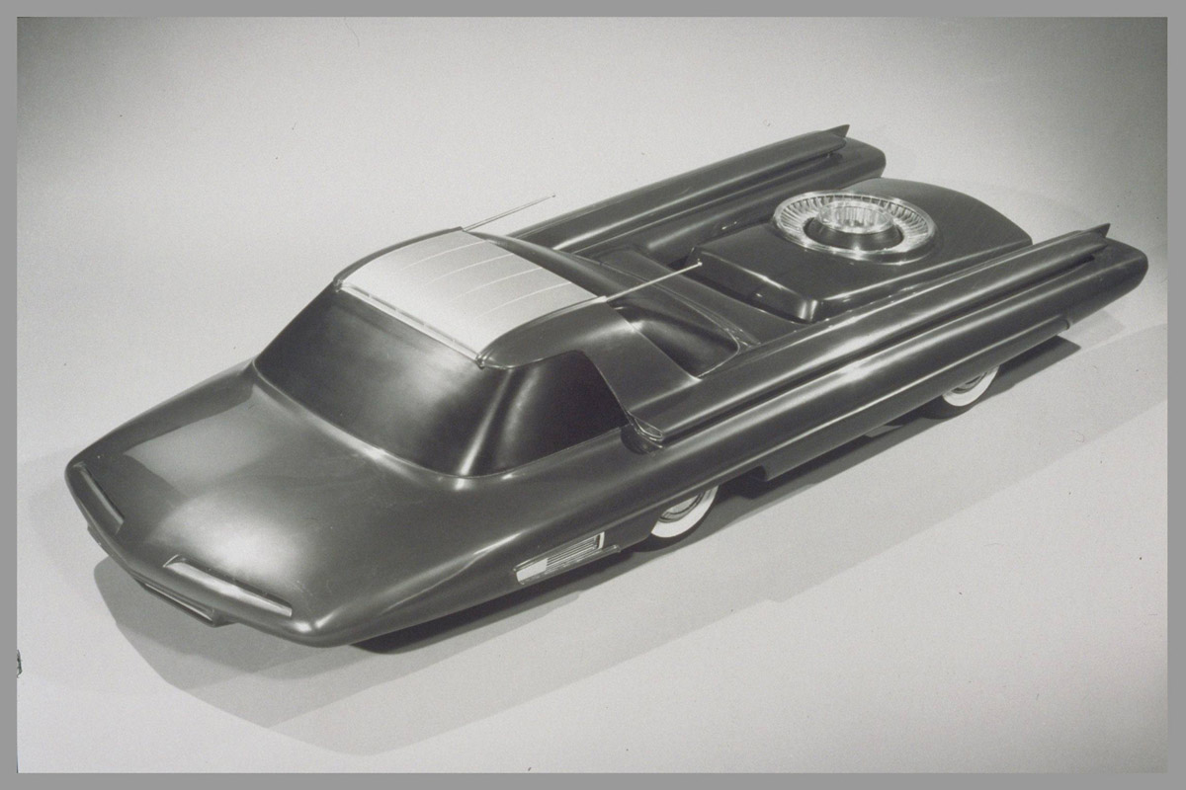
The Ford Nucleon was a nuclear-powered concept car developed by Ford Motor Company in 1958. The vehicle was to be powered by a small nuclear reactor to supply electrical energy to the car. The vehicle featured a power capsule suspended between twin booms at the rear. The capsule, which would contain a radioactive core for motive power, was designed to be easily interchangeable, according to the performance needs and the distances to be travelled.

The passenger compartment of the Nucleon featured a one-piece, wrap around windscreen and compound rear window, and was topped by a cantilever roof. There were air intakes at the leading edge of the roof and at the base of its supports. An extreme cab-forward style provided more protection to the driver and passengers from the reactor in the rear.

It was said that cars like the Nucleon would be able to travel 8000 km or more, depending on the size of the core, without recharging. At the end of the core's life, it would be taken to a charging station, which research designers envisioned as largely replacing gas stations. The car was never built and never went into production, but it remains an icon of the Atomic Age of the 1950s, when concerns and dangers such as radiation poisoning, nuclear waste and the possibility of nuclear meltdown were not completely understood or acknowledged.

(a) The designers estimated the car could travel 8000 km. Explain what would limit the distance the car could travel before recharging. (2 marks)

(b) Modern cars include many safety designs to keep the occupants safe. There were very few ideas for protecting occupants in cars in the middle of the last century. For example, seat belts only became available in motor vehicles, as an optional extra, in 1955.

Lead
Reactor Core
2000 Kg

(i) Explain two ways in which the Nucleon’s design protected the occupant from radiation poisoning. (2 marks)

(ii) Use one of Newton’s Laws of Motion to explain how the reactor position might be considered hazardous in the event of a front end collision. (3 marks)

(c) If the weight due to the lead shielding raised the mass of the car to 3.50 × 10³ kg, determine the minimum power required to accelerate the car from rest to 110 km h⁻¹ (30.6 m s⁻¹) in 7.50 s. Assume no friction. (4 marks)

(d) Estimate the number of decays per second that are necessary to achieve the power in (c), assuming 100% efficiency and given the average nuclear fission produces about 200 MeV for each event. Use the value of 200 kW if you were unable to get an answer in (c).
(3 marks)

(e) Give one advantage and one disadvantage of a car using this type of power plant for motion. (2 marks)

Description | Marks
(a) Size of the core | 1
more fissionable materials, the further you could travel | 1
(b) (i) Distance decreases the amount of exposure | 1
Shield absorbing ability of ionising radiation | 1
(b) (ii) Using Newton’s 1st law | 1
in a head on collision the reactor core will want to continue in a straight line | 1
This is hazardous for the occupants of the car as they will be stopped from the collision, then hit again by the moving reactor core | 1
(c) ΔE = ½ mv² - ½ mu² and 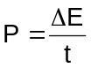 | 1
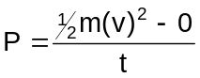 | 1
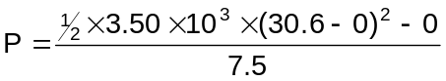 | 1
P = 218 kW | 1
(d) 200 MeV = 2 × 10⁸ eV × 1.6 × 10⁻¹⁹ J eV⁻¹ = 3.2 × 10⁻¹¹J | 1
Number of atoms needed = 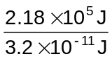 | 1
= 6.8 × 10¹⁵ (alt 6.2 × 10¹⁵) | 1
(e) Reasoned answers, don’t accept “will blow up”  eg will reduce greenhouse emissions from fossil fuels  Radioactive waste disposal will be a problem | 2
 | Total 16

End of questions
ACKNOWLEDGEMENTS

Section One

Question 1 Images adapted from: Brewer, D. (2006). Retrieved February, 2010, from Wikidmedia Commons website: http://commons.wikimedia.org/wiki/File:10th_SFG_parachute_Mail.jpg

Question 3 Image from: NASA, Infrared Processing and Analysis Center (IPAC). Retrieved February, 2010, from Wikipedia website: http://en.wikipedia.org/wiki/file:infrared_dog.jpg

Question 10 Graph adapted from: Fastfission. (2009). Retrieved February, 2010, from Wikimedia Commons website: http://commons.wikimedia.org/wiki/File:Binding_energy_curve_-_common_isotopes-CZ.svg

Section Two

Question 21 Image from: KoenB. (2007). Retrieved February, 2010, from Wikimedia Commons website: http://commons.wikipedia.org/wiki/file:Energy-p-k-i.svg

Section Three

Question 24 Text adapted from: Wikipedia. (2009). Retrieved February, 2010, from: http://en.wikipedia.org/wiki/Ford_Nucleon

Image from: Ford Motor Company. (1958). Retrieved February, 2010, from: Wikipedia website: http://en.wikipedia.org/wiki/Ford_Nucleon
Courtesy of Ford Motor Company.
This examination paper – apart from any third party copyright material contained in it – may be freely copied, or communicated on an intranet, for non-commercial purposes in educational institutions, provided that it is not changed and that the Curriculum Council is acknowledged as the copyright owner. Teachers in schools offering the Western Australian Certificate of Education (WACE) may change the examination paper, provided that the Curriculum Council’s moral rights are not infringed.

Copying or communication for any other purpose can be done only within the terms of the Copyright Act or with prior written permission of the Curriculum Council. Copying or communication of any third party copyright material can be done only within the terms of the Copyright Act or with permission of the copyright owners.

Published by the Curriculum Council of Western Australia
27 Walters Drive
OSBORNE PARK WA 6017

